NOTICE

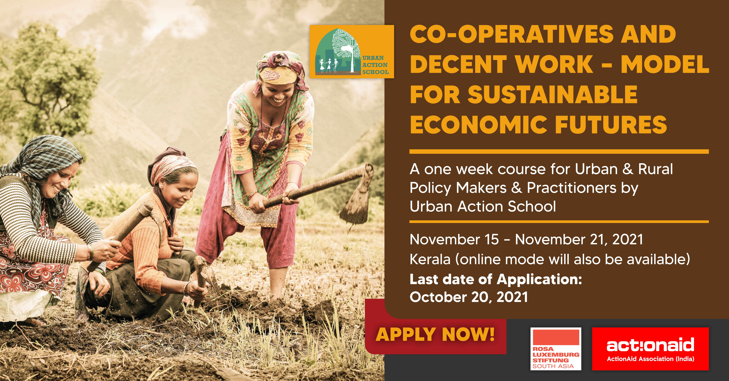

The fast-evolving neo-liberal context sees most countries struggling to achieve a future of work that ensures decent and sustainable opportunities for their citizens. India is very much implicated in this process. Several reports underline that the economy is unable to generate enough jobs for the millions that enter the job market every year, and the jobs that are being created are informal, precarious and low paid. To add to the duress, one can witness the organized sector shrinking, resulting in the informal economy expanding and greater precarity in the world of work.

In this light, the possibilities of cooperatives in improving the situation of workers needs to be better explored and understood. While there are various kinds of cooperatives, the kind that are the focus of this Urban Action School (UAS) course are worker-owned and managed, in which workers democratically control production and self-manage organization.

This edition of the UAS will focus on explaining the concept of cooperatives as an alternative model for sustainable economic futures, which needs to be considered as a strong resilient model for employment generation and ensuring decent work for all.

Application Form to Attend

Co-operatives and Decent work – Model for Sustainable Economic Futures

Urban Action School (UAS) Course (15th November 2021 to 21st November 2021)

Last Date of Submission of Application: 20th October, 2021

Date (on which the application is received):

Number (for admin use):

Course fee, Accommodation, Food, Training Materials. Travel
The workshop expenses will be borne by the organizers. This includes course fee, accommodation, food and training materials. But it may please be noted that only selected candidates (based on applicant information and interaction with shortlisted candidates) will be called to attend the workshop. The candidates need to bear their travel expenses to and from the venue (Kerala).
  - (You may send this by email or fill out and post to the address given at the bottom of the form). Only applications that reach us latest by 20th OCTOBER, 2021 midnight (IST) will be considered.
  - Please use Calibri font, size 12 for filling in the application form. In case of handwritten forms, block letters are preferred. Bulleted format for sharing details is preferred

  - APPLICANT INFORMATION

Section I

a. Name:

b. Date of birth:

c. Gender (Male/Female/Other):

d. Contact details:

Phone:

Email:

Address

e. Country (currently residing):

f. Nationality:

g. Passport /travel document number: (If you are not from India):
Section II
a. Details of Organization/Institution/urban local body/elected body/company: (Please write ‘individual’ if not linked to any organization. And mentioning organization does not mean that you are representing the organization formally in the course)
Name of the organization:
Website URL:
Office contact details:
- Address:
- Phone:
- Email:

b. Work experience (Sector/profession, number of Years of experience):
- Sector:
- Years of experience:
c. Organizations/institutions/peoples movement/companies in which you worked previously (Please mention dates and time period as well)
Name of organization/institution | Period of Involvement

d. Education (Highest level of education achieved along with Name of the Institute and Year of Completion)

e. Other courses attended
Name of the Course attended | Institute | Dates attended from and to (dd/mm/yy) | Degree/ Certificate awarded

f. Language proficiency: (Please tick √ the appropriate)
Language (please add languages below) | Fluent (Speak, Read and write) | Speak but do not read | Read but do not speak | Do not Understand
English
Hindi

  - (Add languages and rows as per requirement)
  - Section III
  - a. Areas of interest: (e.g. labour, poverty, economics, politics, alternatives, social work, political activism, research methodology, social media, etc. This is to help us to integrate your interests in the course if possible.)

b. Why do you wish to participate in this course? (Please answer in few sentences or bulleted is preferred and maximum of 150 words)

c. Tell us something about your organization/ the cause that you are associated with/ passionate about. You could include success/ failure snippets in the same. (Please answer in few sentences or bulleted is preferred and maximum of 100 words)

Section IV

a. Are you member of a social group that has special status? (SC, ST, OBC, minority…) If so please specify:
b. Do you have any special needs/ disability? (Please give details - this is to help to make you comfortable and improve your participation)

c. Contact for emergency:

Name:

Phone (with ISD/STD code):

Email:

Any other Information you wish to share:

Send your application by email to: ajay.rana@actionaid.org;
Please mention the subject line as: “Application for Urban Action School”
If you cannot send by email, the hard copy can be sent to:
The Course Coordinator, Urban Action School,
ActionAid India, F-5, First Floor Kailash Colony,
New Delhi -110048

For questions and queries please call:
Phone: +91-11-40640500; + 91-11- 40640559; Mobile :9873084993, 9799496241

